MY_ASSISTANT

***CHAT BOT for DTH SERVICE***

GitHub link

***Getting Started***

Step 1: Setting up a Dialog Flow account

1. Go to <https://dialogflow.com/>

2. Click on ‘’go to console” in the top right corner

3. Login with a Gmail account when prompted

Step 2: creating an agent

4. Start off by clicking “creating an agent” in the column menu to your left

5. Give your bot’s name! “MY_ASSISTANT”

6. Be sure to select time zone and language required

7. Click on create

Congratulations you have created your first agent. Once the system recognizes it. Will see column menu expands

***Level2: Bot development***

Step 1: checking out the present intents This is just telling the bot what to do when welcoming someone or when the bot doesn’t know the answer to their question. “Click on default welcome intent “

Scroll to the “training phrases” section. Create new intents

1. To create new intent click on “+”

Well create intents for each of these question types. Then feed in the appropriate expressions and responses.

We can develop as many intents as we want. After this click on save to save our intent and responses

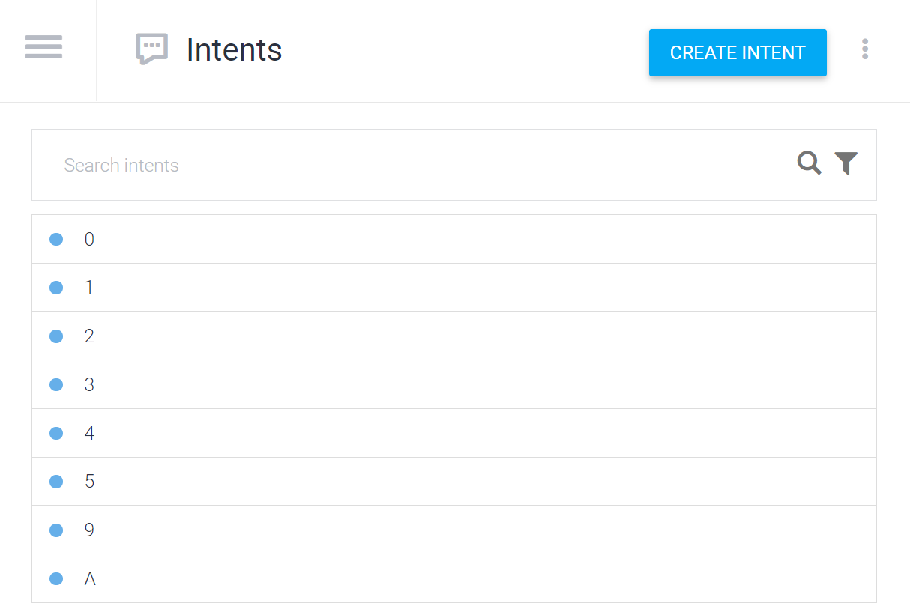

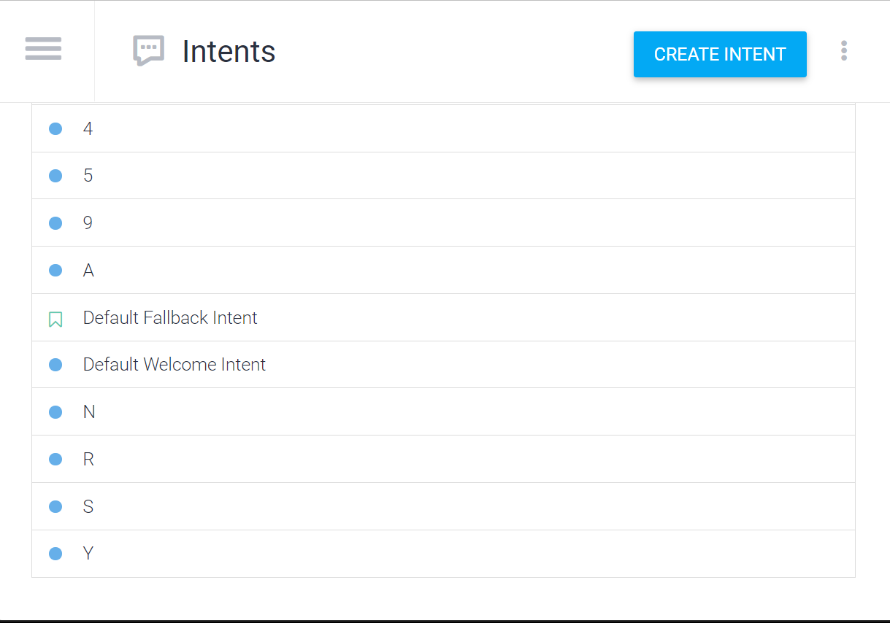

***Actions and parameters***

Step 1: Creating Actions and parameters

1.Name the parameters Example: Goal

2.enter the entity that you created. Start with the “@” symbol Ex: @Category

3.enter the corresponding “value” starting with “$” sign Ex: $goal

4.check the “required “box to enter the “prompts”

Step2: Adding expressions

5.Proceed to add the training phrases

6. notice automatic colour coded annotation

7. If you notice automatic colour coded annotation, manually annotate by right click the phrases and assigning the entities

Step 3: Adding the response

8.Draft a concluding response

9. include the “$value” in the message So that it can copy useful information from the parameters.

10. Toggle on the intent as “end of the conversation”

Integration Actual chatbot deployment on platforms like our websites etc. is a complicated procedure that required publishing the bot. but we can still get an idea of how the chatbot would appear when functional here’s how 1. Navigate to the “integration” section in the left column 2. Toggle “web demo” on, then click to enter.

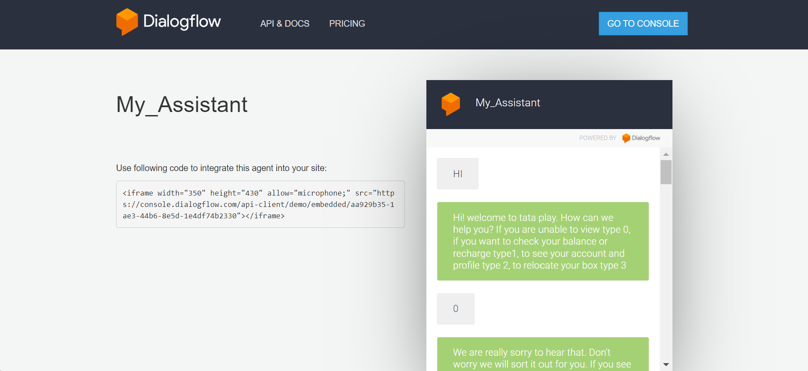

***Screenshots showing how my chat bot looks and responds***

